SHRI RAMDEOBABA COLLEGE OF ENGINEERING AND MANAGEMENT, NAGPUR



Electronic Design Workshop Project Report

(5TH SEM, SESSION 2025-2026, ECP5005)

“MineGuard : IoT Based Health and Gas Monitoring System for Miners ”

Submitted By

Batch: A1
Group Number: A1-1.

Akanksha Warkad (Roll No.-02, Sec-A)
Akul Kute (Roll No.-03, Sec-A)
Ananya Botkawar (Roll No.-05, Sec-A)
Arpita Singh (Roll No.-14, Sec-A)
Ashutosh Keshpage(Roll No.-17, Sec-A)

Workshop Coordinator: Prof. A Jaiswal

Department of Electronics and Communication Engineering
SHRI RAMDEOBABA COLLEGE OF ENGINEERING AND MANAGEMENT, NAGPUR

Department of Electronics and Communication
Engineering

CERTIFICATE

This is to certify that the project report titled “MineGuard: Iot Based Health and Gas Monitoring System for Miners” is a bona fide work of

      - Akanksha Warkad (Roll No.-02, Sec-A)
      - Akul Kute(Roll No.-03, Sec-A)
      - Ananya Botkawar (Roll No.-05, Sec-A)
      - Arpita Singh (Roll No.-14, Sec-A)
      - Ashutosh Keshpage (Roll No.-17,Sec-A)

Submitted as a part of term work in 5th semester in Electronic Design Workshop (ECP5005) during the academic session 2025-2026.

Date: 1/11/25
Place: Nagpur

Name & Signature
(Workshop Coordinator)

Contents

- Introduction Pg No.1

- Impact of Project on society and the environment Pg No.2

- Block diagram and Functional description Pg No.3

- Circuit diagram and its description Pg No.4

- PCB layout and Artwork Pg No.9

- Working of Project PgNo.11

- Result and Future Scope PgNo.14

- References/ Citations PgNo.18

- Introduction

The advancement of embedded systems and Internet of Things (IoT) technologies has enabled the development of compact and intelligent monitoring devices for real-time safety and health assessment. This project presents a wearable multi-sensor safety system designed to monitor vital signs and environmental conditions simultaneously. It integrates physiological sensors for health monitoring and gas sensors for environmental hazard detection, with data transmitted wirelessly using the ESP-NOW communication protocol between ESP32 modules.

The system employs two wearable sensor modules placed strategically on the body. The hand-mounted module measures heart rate and body temperature using a MAX30102 pulse sensor and a DS18B20 digital temperature sensor, while the back-mounted module houses an MQ-series gas sensor for detecting hazardous gases such as carbon monoxide (CO), methane (CH₄), and hydrogen sulfide (H₂S). Each module is controlled by an ESP32 microcontroller, which collects data from the sensors and transmits it wirelessly through ESP-NOW to a receiver node for processing and alert generation.

The ESP-NOW protocol, developed by Espressif Systems, enables direct device-to-device communication with low latency, low power consumption, and no dependency on external network[13],[14]. This makes it ideal for wearable and field-deployable safety systems. Previous research supports the use of low-cost microcontrollers and wireless protocols for continuous monitoring of physiological and environmental parameters [3]–[6]. Furthermore, Espressif’s patented methods for device discovery and communication [15] strengthen the reliability of ESP-NOW for distributed sensor networks.

The proposed system provides a low-cost, energy-efficient, and scalable solution for continuous safety monitoring. By combining health and environmental data within a wireless network, it ensures early detection of dangerous conditions, improving worker safety in high-risk industrial environments.

- Impact of Project on society and the environment
The proposed wearable multi-sensor safety system has a meaningful impact on society and the environment by improving personal safety, occupational health, and environmental protection. By integrating physiological and environmental sensors into a single wearable unit, the project ensures real-time monitoring of both human health and surrounding atmospheric conditions. This contributes directly to reducing workplace hazards, preventing accidents, and promoting sustainable safety practices[3],[4].
From a societal perspective, the project enhances the safety and well-being of workers in hazardous environments such as mines, factories, and chemical plants. The system provides early detection of toxic gases and continuous monitoring of body vitals, enabling timely preventive measures[5],[6]. It also promotes awareness about occupational health and the adoption of smart safety devices in industrial sectors.
From an environmental standpoint, the project contributes to safer and cleaner working conditions by detecting and reporting harmful gas leaks, thus minimizing pollution and ecological damage[13],[16]. Additionally, the use of low-power communication through ESP-NOW and efficient components like the ESP32 promotes sustainable technology design by reducing energy consumption and electronic waste[14],[15].
Societal Impact
- Enhances worker safety in hazardous industries such as mining and chemical plants.
- Provides early detection of toxic gases and abnormal health conditions.
- Supports quick emergency response and accident prevention.
Individual Impact
- Enables continuous personal health and safety monitoring.
- Provides real-time alerts to prevent health-related incidents.
Environmental Impact
- Detects gas leaks early, reducing air pollution and environmental damage.
- Encourages safer industrial practices and sustainable monitoring.

- Block diagram and Functional description

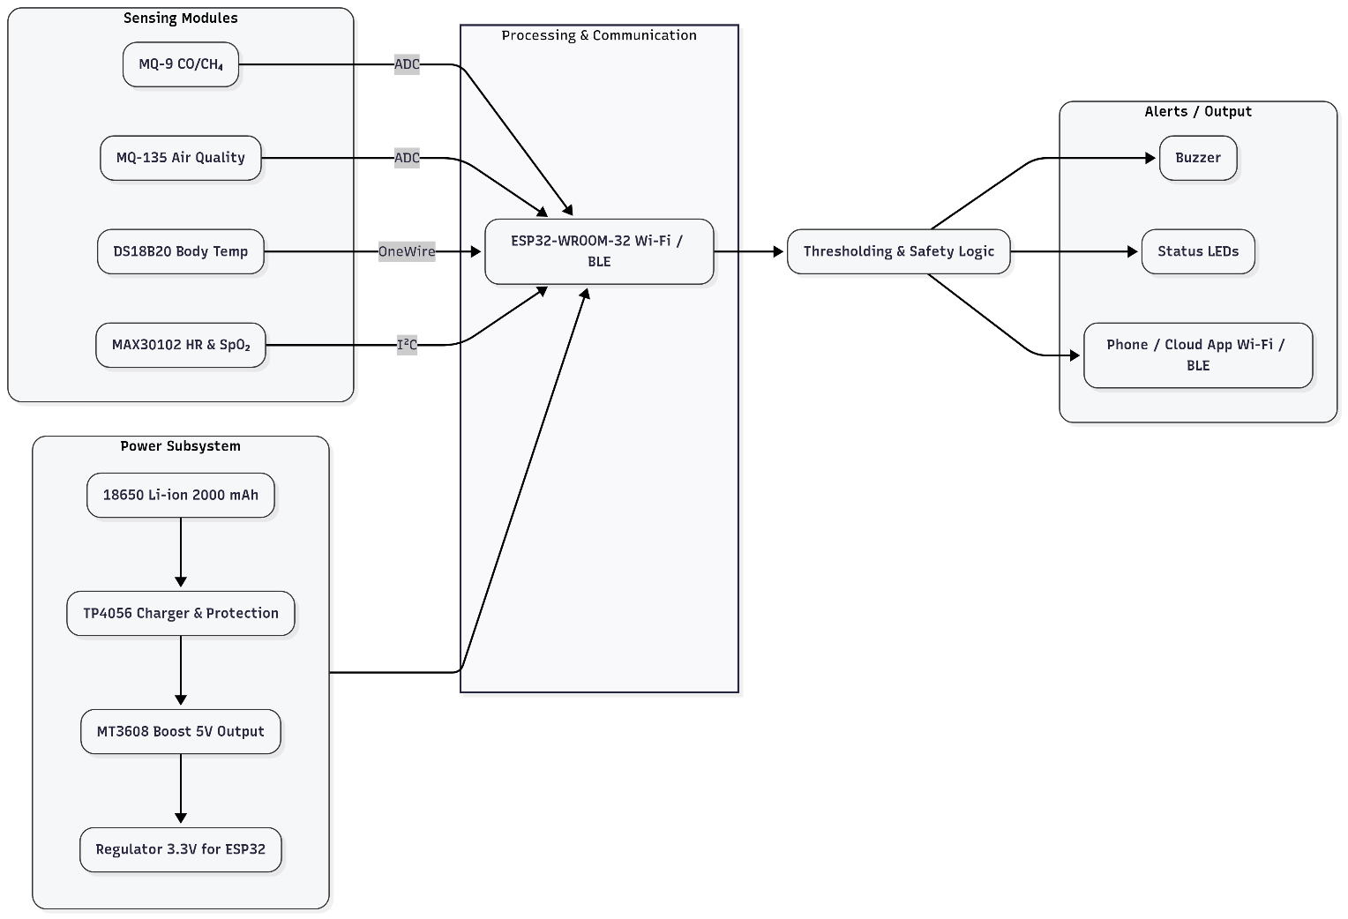
Figure 3.1 - Block Diagram of project

The overall operation is divided into three major subsystems:
Sensing Module, Processing & Communication Unit, and Alert/Output Unit, all powered by an efficient Power Subsystem.

1. Sensing Modules
- MQ-9 (CO/CH₄ Sensor): Detects carbon monoxide and methane concentrations in the environment.
- MQ-135 (Air Quality Sensor): Measures air quality by detecting toxic gases and pollutants.
- DS18B20 (Temperature Sensor): Measures body temperature through OneWire communication.
- MAX30102 (Heart Rate & SpO₂ Sensor): A physiological sensor that measures heart rate and blood oxygen levels using photoplethysmography (I²C interface).

2. Processing and Communication
- The ESP32-WROOM-32 microcontroller serves as the central processing unit. It acquires analog and digital signals from the sensors via ADC, I²C, and OneWire interfaces.
- Data is processed and analyzed based on pre-defined safety thresholds.
- The ESP32 also handles wireless communication through ESP-NOW protocol , enabling data transfer to a receiver node.

3. Thresholding and Safety Logic
- The processed data is compared with predefined safe limits for gas concentration, temperature, heart rate, and oxygen level.
- If abnormal conditions are detected, the ESP32 triggers an alert mechanism through the output module.

4. Alerts and Output
- Buzzer: Provides audible warnings in case of hazardous conditions.
- Status LEDs: Indicate system operation status and safety alerts visually.
- Dashboard : Sensor data is transmitted to a central dashboard or control room using the ESP-NOW protocol with o data hopping between ESP32 nodes to extend range and ensure reliable communication. The received data is displayed in real time for continuous monitoring and record-keeping. Supervisors can view live readings, system status, and receive automatic alerts for quick decision-making and emergency response.

5. Power Subsystem
- A 18650 Li-ion battery (2000 mAh) powers the system, providing long operational life.
- The TP4056 charging module ensures safe charging and overcurrent protection.
- A MT3608 boost converter raises the voltage to 5V, and a 3.3V voltage regulator supplies stable power to the ESP32 and sensors.

- Circuit diagram and its description
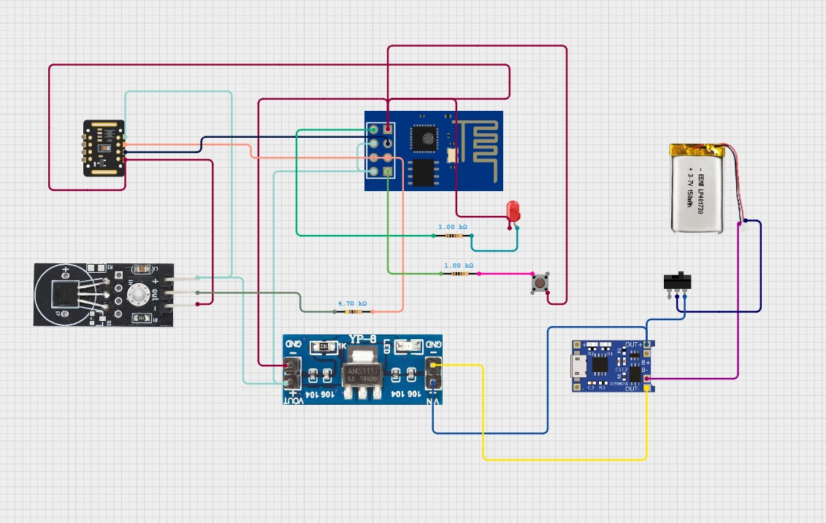

Figure 4.1 Circuit Diagram of Hand PCB

The circuit integrates multiple functional blocks on the PCB:

1. Power Supply Section
- A 3.7V Li-Po battery serves as the primary power source.
- The TP4056 module ensures safe charging, over-voltage, and over-current protection when charged via micro-USB.
- The output of TP4056 passes through an AMS1117 voltage regulator, which provides a constant 3.3V supply to the ESP8266 and sensors.
- A power switch allows controlled power ON/OFF operation.

2. Control Unit – ESP8266 Module
- The ESP8266 acts as the microcontroller and Wi-Fi transmitter.
- It interfaces with the MAX30102 and DS18B20 sensors, processes the readings, and sends data wirelessly via Wi-Fi or ESP-NOW protocol to a monitoring dashboard.
- It operates at 3.3V logic, powered through the AMS1117 regulator output.
- It also controls the LED and push button to indicate operation and trigger data collection events.

3. MAX30102 (Pulse Oximeter Sensor)
- The MAX30102 module uses infrared and red LEDs along with a photodiode to measure heart rate and oxygen saturation (SpO₂).
- The amount of light reflected back from blood vessels is proportional to oxygen content, enabling precise health monitoring.
- It communicates with the ESP8266 using the I²C protocol (SDA and SCL lines).
- The data is processed in real time and transmitted wirelessly.

4. DS18B20 ( Digital Temperature Sensor)
- The DS18B20 is a digital one-wire temperature sensor capable of measuring temperature with an accuracy of ±0.5°C.
- It connects to the ESP8266 using a single data line (one-wire protocol) and requires a 4.7 kΩ pull-up resistor between the data line and VCC.
- This sensor measures body or ambient temperature, and the data is used along with heart rate and SpO₂ readings for a comprehensive health profile.

5. Indicator and Control Components
- A red LED (with 1 kΩ current-limiting resistor) is used as a status indicator.
- A push button is connected to a ground pin of ESP8266 to serve as a manual trigger for starting data measurement or resetting the system.

6. Battery Charging and Regulation Section
- The TP4056 module manages Li-Po battery charging via USB input and provides safe cut-off when fully charged.
- AMS1117-3.3V regulator steps down the voltage to 3.3V required for ESP8266 and sensors

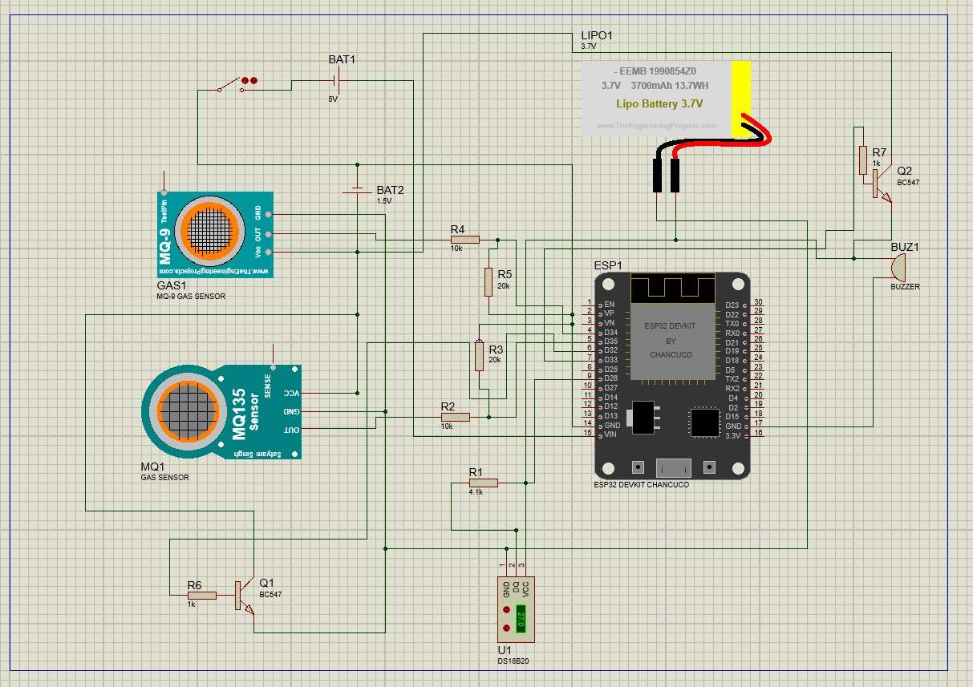

Figure 4.2 Circuit Diagram of Back PCB

The circuit integrates multiple functional blocks on the PCB:

1. Power Supply Section
- Li-Po Battery (3.7 V) serves as the main DC source for the circuit.
- The supply is regulated using and potential divider (3.3 V voltage regulator) which ensures the ESP32 and sensors receive stable voltage.
- Additional headers and pads on the PCB allow battery charging through a TP4056 charging module, ensuring safe charging and discharge protection.

2. Microcontroller Section
- The ESP32 module (ESP32 DevKit) is the heart of the circuit.
- It processes sensor inputs, performs decision logic, and provides wireless communication ( ESP-NOW) for data transmission to a dashboard or control system.
- The microcontroller pins are routed on the PCB to the respective sensor, power, and output connections via copper tracks.

3. Sensor Section
MQ-9 Gas Sensor
- Detects flammable gases such as Carbon Monoxide (CO) and Methane (CH₄).
- Produces an analog output proportional to gas concentration.
- Used for identifying leakages and unsafe gas levels, ensuring environmental safety.
MQ-135 Air Quality Sensor
- Senses air pollutants like CO₂, NH₃, and NOx gases.
- Provides an analog signal indicating overall air quality.
- Enables continuous monitoring of pollution and air freshness in the surroundings.

DS18B20 Temperature Sensor
- A digital one-wire sensor that measures ambient temperature with high accuracy (±0.5°C).
- Provides temperature compensation for MQ sensors, improving gas reading accuracy.
- Compact, stable, and ideal for environmental data calibration.

4. Output and Alert Section
- The circuit includes a buzzer (BUZ1) and indicator LED driven by BC547 transistors (Q1 & Q2) used as low-side switches.
- These components provide both visual and audible indications when gas concentration exceeds preset threshold values.
- The use of transistors prevents high current loads from directly affecting the ESP32 pins.

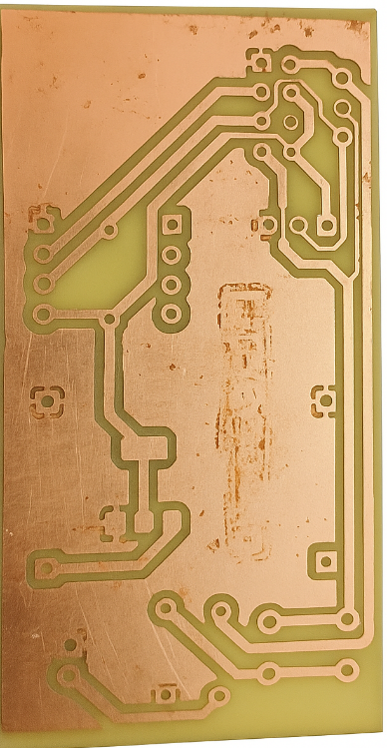
- PCB layout and Artwork
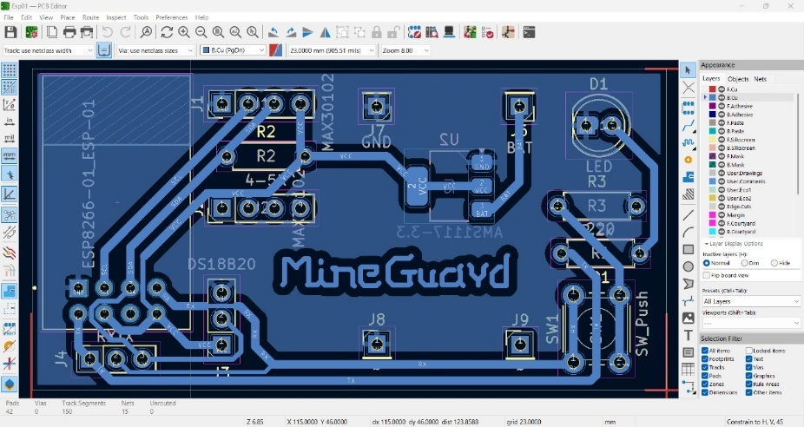
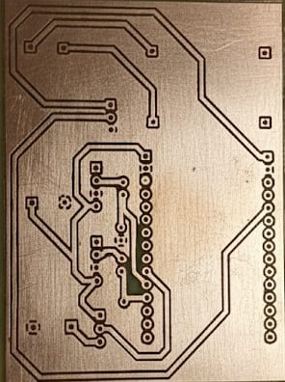
Figure 5.1 Hand PCB Layout on Kicad Software
Figure 5.2 Hand PCB Layout Artwork
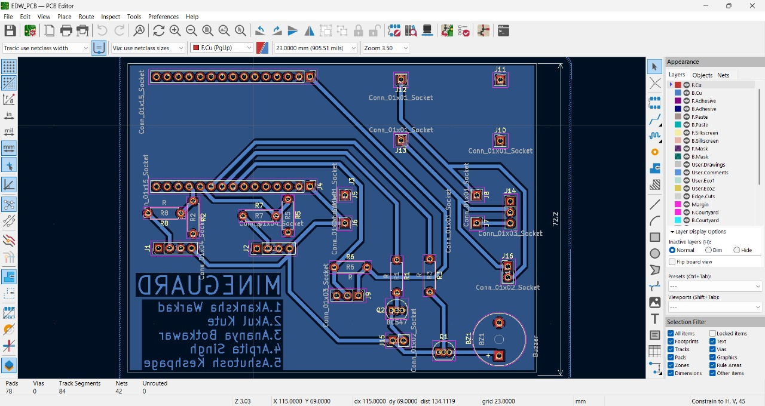

Figure 5.4 Back PCB Layout Artwork
Figure 5.3 Back PCB Layout on Kicad Software

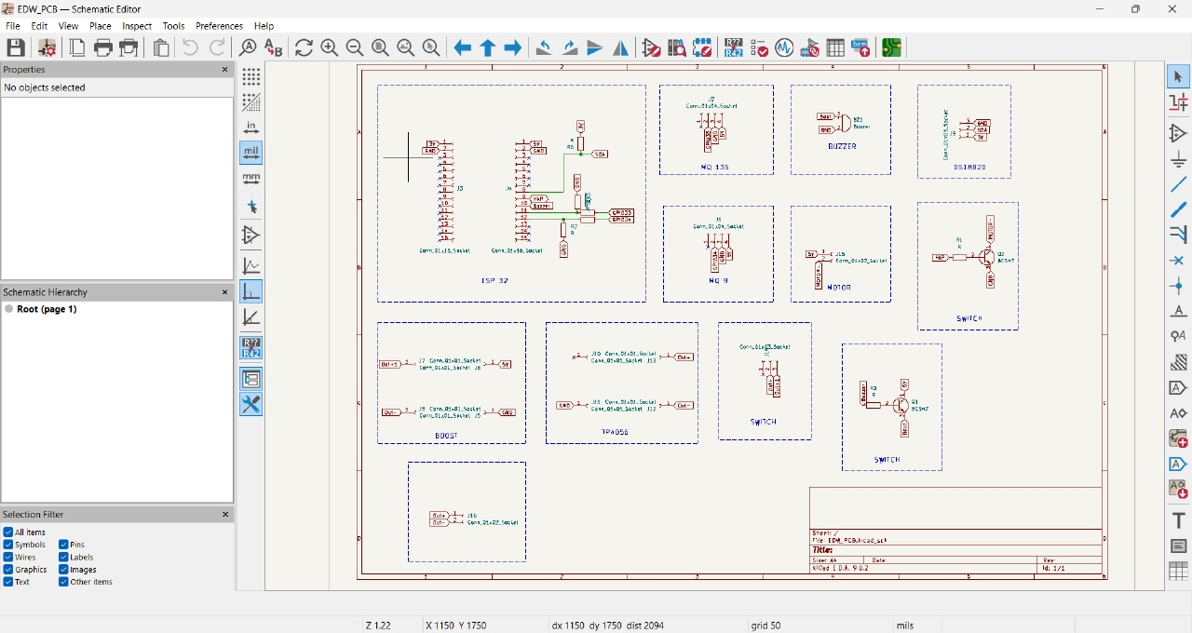

Figure 5.5 Circuit in KiCad Schematic Editor of Back PCB

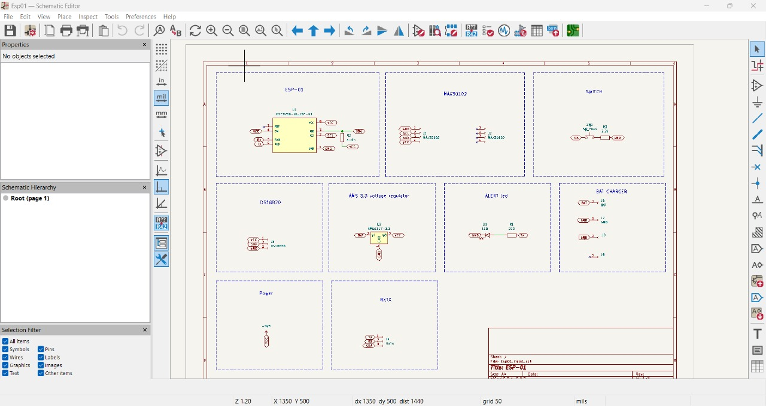

Figure 5.6 Circuit in KiCad Schematic Editor of Hand PCB

- Working of Project

1. System Setup
- Each worker wears a small device called Labour ESP32.
- It has sensors to measure:
  - Heart rate and oxygen (MAX30102)
  - Body temperature (DS18B20)
  - Gas concentration (MQ-9, MQ-135)
  - Motion or fall detection (accelerometer/gyroscope)
- Several Link ESP32 modules are placed throughout the mine tunnel to pass data between workers and the control room.
- A Control ESP32 acts as a middle node, and the Control Room ESP32 is connected to a PC for monitoring.

2. Normal Operation (Monitoring Mode)
- Every worker’s Labour ESP32 continuously collects health and environmental data from its sensors.
- The device sends this data wirelessly using the ESP-NOW protocol to the nearest Link ESP32.
- The Link ESP32 forwards the collected data to the Control ESP32.
- All information from Control Room ESP32, displays data on a dashboard.
- Supervisors can see every worker’s status in real-time — heart rate, temperature, gas levels, etc.

3. Alert Operation (Emergency Mode)
- If any abnormal reading is detected — for example:
  - Gas concentration too high
  - Worker’s oxygen level or temperature abnormal
- The Labour ESP32 immediately creates an alert signal.
- This alert is instantly sent to the nearest Link ESP32.
- The Link ESP32 then does two things:
  - Broadcasts the alert to all nearby workers’ devices (so everyone gets a buzzer/vibration warning).
  - Sends the alert upward to the Control ESP32, then to the Control Room ESP32 for logging and supervisor warning.
- The Control Room ESP32 activates alarms, lights and that warn control staff.
- Even if internet or control connection fails, nearby workers still receive alerts locally through ESP-NOW rebroadcast — this ensures instant safety warnings.

Flowchart:
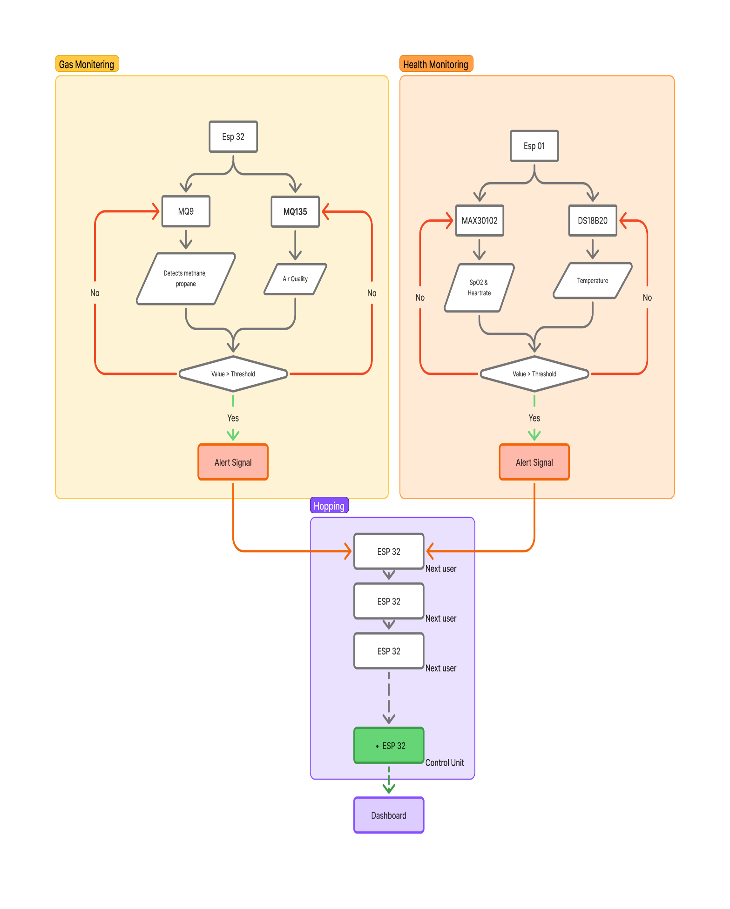

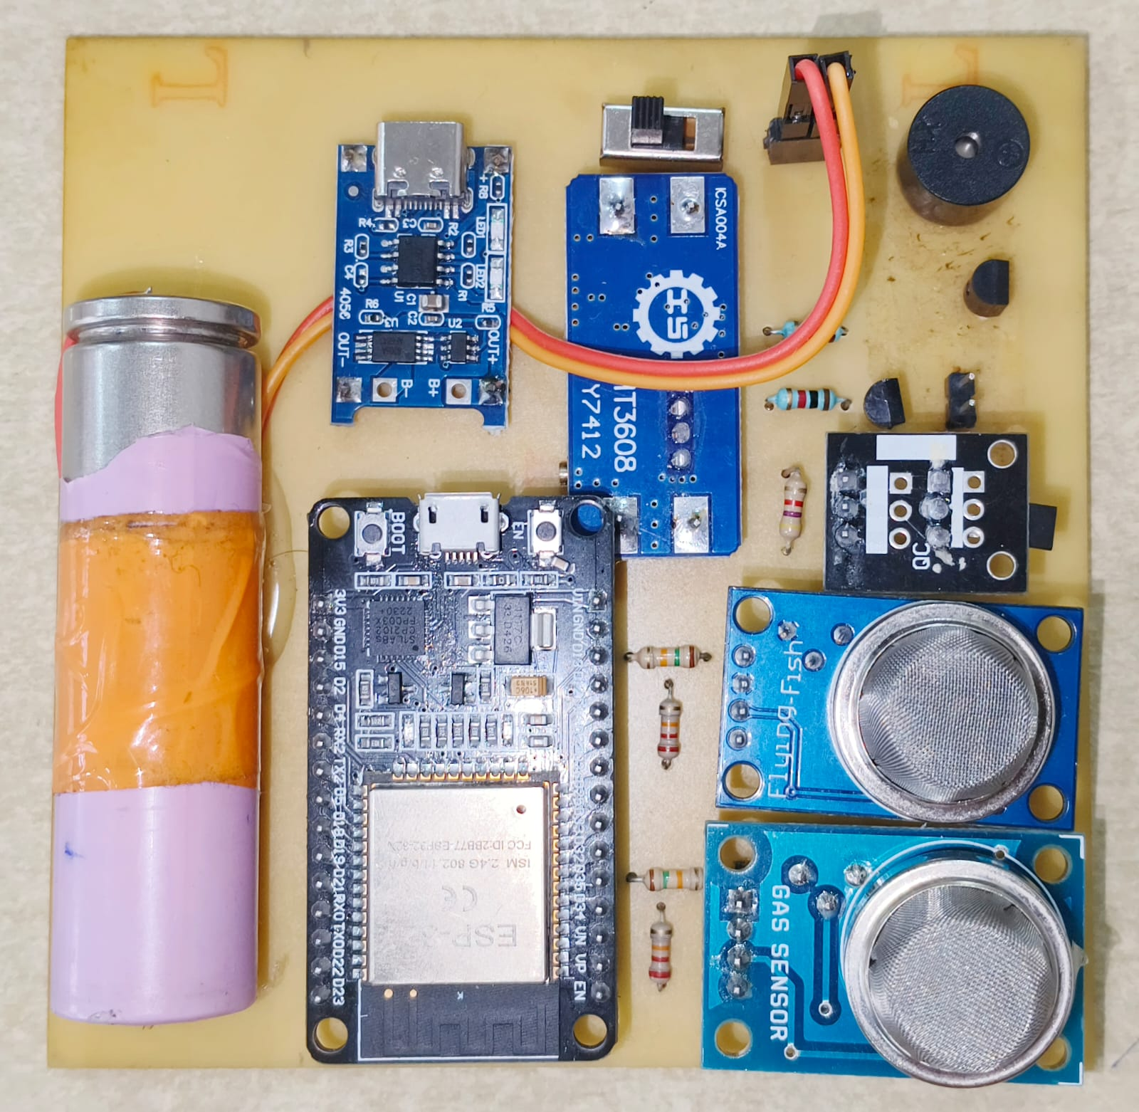

Figure 5.7 Mounting on Back PCB
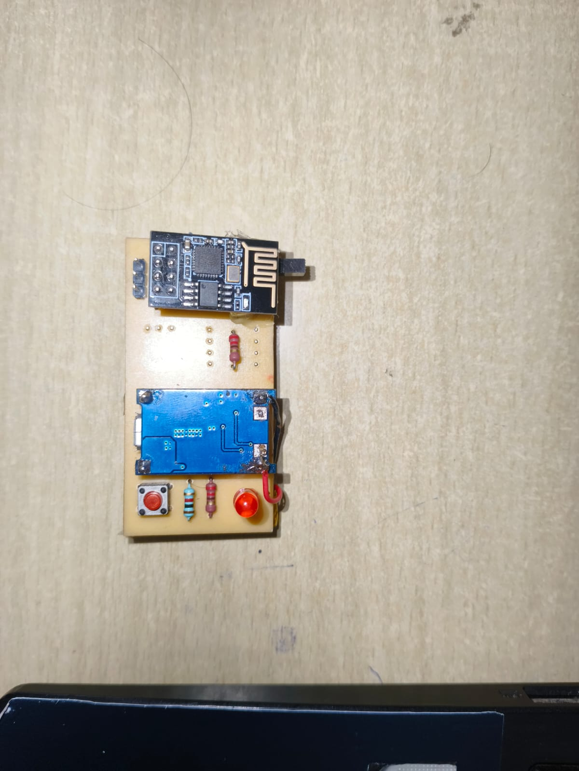

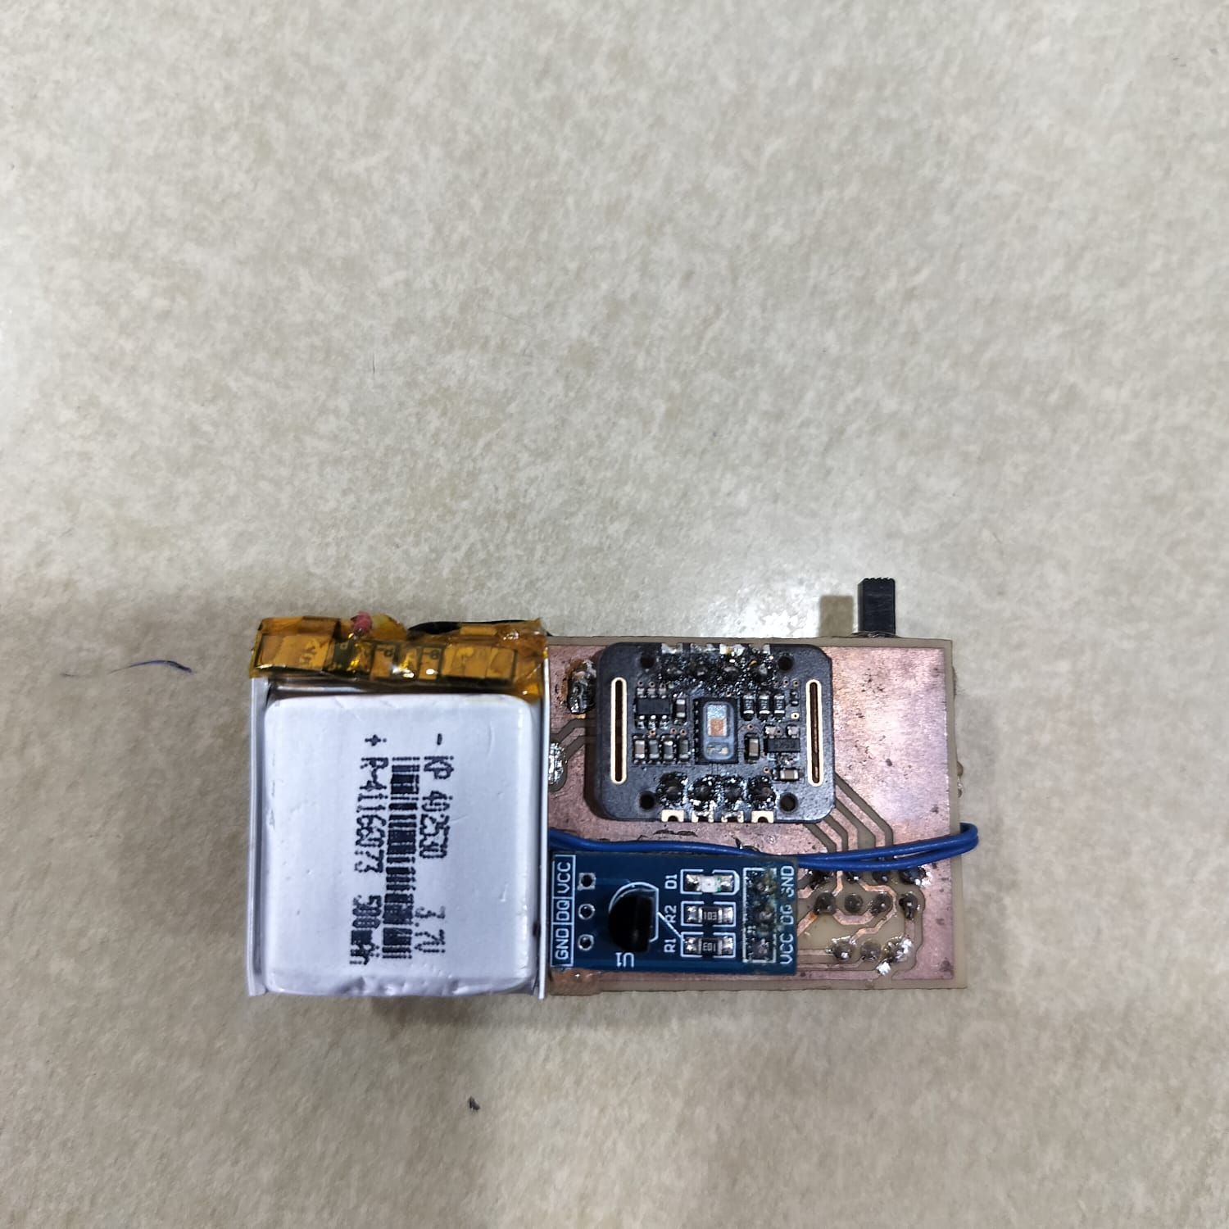

Figure 5.8 Mounting on frontside of Hand PCB
Figure 5.9 Mounting on backside of Hand PCB

- Result and Future Scope

Project Findings:
- The system successfully monitors workers’ health (heart rate, SpO₂, body temperature) and environment conditions (gas levels, air quality, temperature).
- The ESP-NOW protocol allows fast and reliable wireless communication without Wi-Fi or internet.
- The system gives instant alerts to workers through control room during emergencies.
- Both health and environmental PCBs are compact, portable, and suitable for underground mining conditions.

Circuit Advantages:
- Provides real-time monitoring of workers and surroundings.
- Fast alert response during dangerous gas levels or abnormal health conditions.
- Low power consumption and long battery life.
- Wireless and flexible—no need for wired connections.
- Cost-effective and easy to expand for more workers or tunnels.

Circuit Limitations:
- Limited wireless range inside deep tunnels.
- Requires regular battery charging.
- Gas sensors need calibration for accurate readings.

Applications:
- Industrial gas monitoring in chemical or oil plants.
- Tunnel and metro safety monitoring.
- Rescue operations in disaster-prone or hazardous areas.

Conclusion :

The developed wearable multi-sensor safety system successfully integrates physiological and environmental monitoring into a single, compact, and energy-efficient device. Using sensors such as MAX30102, DS18B20, and MQ-series gas sensors, the system continuously measures key health and environmental parameters including heart rate, body temperature, and gas concentration levels[3]-[6]. The ESP32 microcontroller, utilizing the ESP-NOW protocol, ensures reliable and low-latency wireless communication between nodes without dependence on external networks[13],[14].
This design demonstrates a low-cost, portable, and scalable solution for real-time safety monitoring in industrial, mining, and remote field environments. The implementation of threshold-based alerting through buzzers, LEDs, and a centralized dashboard enhances worker protection and situational awareness. Overall, the project effectively addresses the need for continuous monitoring and early warning systems, thereby contributing to improved human safety and environmental responsibility[15],[16].

Future Scope :

- Integration with cloud platforms (Blynk, Firebase, ThingSpeak) for remote data logging and real-time monitoring.
- Implementation of AI/ML algorithms to analyse trends and predict abnormal health or environmental conditions.
- Inclusion of GPS/GNSS modules for real-time location tracking in emergency scenarios.
- Implementation of LEACH protocol (Low Energy Adaptive Clustering Hierarchy) for improved communication efficiency, load balancing, and energy conservation in large-scale sensor networks.

Economics:

COMPONENTS | PRICE
MQ9 Carbon Monoxide, Methane and LPG Gas Sensor Module | ₹125.68
MQ135 Air Quality/Gas Detector Sensor Module For Arduino MQ 135 | ₹130.40
MAX30102 Heart Rate and Pulse Oximeter Sensor Module (Black) | ₹236.00
LiPo Battery 3.7v 500mAh Rechargeable | ₹160.00
MT3608 2A Max DC-DC Step Up Power Module Booster Power Module | ₹40.72
Jumper Wire Male to Male 10 wires bunch Connectors | ₹50.00
DS18B20 Temperature Sensor Module | ₹81.00
Solder Wire 2gm | ₹10.00
Header Female 40x1 pin 2.54mm Pitch 10mm length Berg Strip flow solder pack of 2pcs | ₹32.00
TP4056 with C Type USB module 1A Li-Ion 18650 Battery Charging Board with Protection 5V 1A | ₹39.00
MT3608 2A Max DC-DC Step Up Power Module Booster Power Module | ₹40.00
Copper Clad 4x4 inch Single Sided Laminate PCB | ₹21.00
Buzzer 3V Active Electromagnetic Buzzer | ₹14.00
ESP-01 ESP8266 Serial WIFI Wireless Transceiver Module | ₹100.00
ESP WROOM 32 MCU Module Version: 1.1 | ₹343.00
TOTAL | ₹1422.8

Project Management :

Name | Area of contribution | Detailed Tasks Performed
Akanksha Warkad | Presentation and Research Support | -Designed the project PowerPoint presentation.  - Contributed to literature review and background study.  - Participated in circuit implementation .
Akul Kute | Hardware Development, Testing, and Fabrication | - Calibrated sensors modules  - Performed breadboard testing.  - Handled PCB etching, soldering, and component assembly.  - Designed and printed 3D enclosure parts for wearable modules.
Ananya Botkawar | Report Writing Research , Software Assistance | -Prepared the detailed project report and documentation.  - Contributed to literature survey and reference compilation.  - Assisted in ESP32 programming, debugging, and data communication setup.
Arpita Singh | Dashboard Development and Software Integration | - Designed and implemented the real-time monitoring dashboard for data visualization.  - Worked on interfacing ESP32 with the dashboard for live data updates.
Ashutosh Keshpage | Circuit Design, Simulation, and PCB Layout | -Created circuit schematics using KiCad and performed circuit simulations.  - Designed PCB layout and verified routing and component placement.  - Assisted in breadboard testing .  - Managed documentation of hardware setup and circuit diagrams.

- References/ Citations

Book
[1] A. Bahga and V. Madisetti, Internet of Things: A Hands-On Approach, 1st ed. Blacksburg, VA, USA: VPT, 2014, ch. 3, sec. 2, pp. 45–68.

[2] J. Boylestad and L. Nashelsky, Electronic Devices and Circuit Theory, 11th ed. Boston, MA, USA: Pearson Education, 2015, ch. 5, sec. 3, pp. 150–172.

Conference Paper / Journal Paper
[3] M. Z. Dini, A. Rakhmatsyah, and A. A. Wardana, “Detection of oxygen levels (SpO₂) and heart rate using a pulse oximeter for classification of hypoxemia based on fuzzy logic,” Jurnal Ilmiah Teknik Elektro Komputer dan Informatika (JITEKI), vol. 8, no. 1, pp. 17–26, 2022. DOI: 10.26555/jiteki.v8i1.22139.

[4] S. Sakphrom, S. Sittichivapak, and C. Limsakul, “Intelligent medical system with low-cost wearable sensors for vital sign monitoring,” Sensors, vol. 21, no. 2, pp. 523–534, Jan. 2021. DOI: 10.3390/s21020523.

[5] Y. Gao, H. Wu, and F. Wang, “IoT-based environmental monitoring system with gas sensors and wireless communication,” IEEE Internet of Things Journal, vol. 9, no. 12, pp. 10844–10853, 2022. DOI: 10.1109/JIOT.2022.3143258.

[6] J. Lin, T. Lin, and C. Chen, “Wireless gas leakage detection and monitoring using low-power sensors,” Sensors and Actuators B: Chemical, vol. 345, pp. 130347–130355, 2021. DOI: 10.1016/j.snb.2021.130347.

Manual
[7] MAX30102: High-Sensitivity Pulse Oximeter and Heart-Rate Sensor, 1st ed., Analog Devices Inc., Norwood, MA, USA, 2017, pp. 1–18.

[8] DS18B20 Programmable Resolution 1-Wire Digital Thermometer, 2nd ed., Maxim Integrated, San Jose, CA, USA, 2015, pp. 3–14.

[9] MQ-9 Gas Sensor Module Datasheet, Hanwei Electronics, Zhengzhou, China, 2020, pp. 5–10.

Software
[10] ESP-IDF (v5.0), Espressif Systems. Accessed: Oct. 2025. [Online]. Available: https://docs.espressif.com/projects/esp-idf/en/latest/esp32/

[11] KiCad EDA Software Suite (Version 8.0), KiCad Developers. Accessed: Oct. 2025. [Software]. Available: https://www.kicad.org/

[12] Arduino IDE (Version 2.3.2), Arduino Software LLC. Accessed: Oct. 2025. [Software]. Available: https://www.arduino.cc/en/software

Website
[13] Espressif Systems, “ESP-NOW Wireless Communication Protocol,” Espressif Official Website. [Online]. Available: https://www.espressif.com/en/solutions/low-power-solutions/esp-now. (Accessed: Oct. 2025).

[14] Espressif Systems, “ESP-NOW — ESP-IDF Programming Guide,” Espressif Documentation. [Online]. Available: https://docs.espressif.com/projects/esp-idf/en/stable/esp32/api-reference/network/esp_now.html. (Accessed: Oct. 2025)

[15] Justia Patents, “Method for Discovering Devices in a Mesh Network,” Espressif Systems (Shanghai) Co., Ltd., U.S. Patent 11,595,805. [Online]. Available: https://patents.justia.com/patent/11595805. (Accessed: Oct. 2025).

[16] Analog Devices, “MAX30102 Pulse Oximeter and Heart Rate Sensor Overview,” Analog Devices. [Online]. Available: https://www.analog.com/en/products/max30102.html. (Accessed: Oct. 2025).

